Design Specification
Document Name: DS-Development_ID-Please enter the title of the Development
Program: Development_ID, Please enter the title of the Development
Approval

Change History
All italic and blue text in this document is for descriptive purposes only.
Note by: before finishing and storing the document all reference field in the document should be updated and refreshed. This can be done individually by navigation to the reference field and pressing key “F9” or by selecting the page preview functionality and switching back to normal edit mode. The table of contents has to be updated individually itself and will not be effected by the page preview mode.

Version | Author | Description of Change
00 |  | ZHHO 95190
01 |  | Initial Creation, EVFPU:
Table of Contents
1 Overview 4
1 Doc41 Web UI Core System Architecture 4
2 Framework 4
3 Scope Description 5
4 Terms and Definitions 5
5 Cross References 6
6 Programming Specification 7
6.1 Form / Report Specification 7
6.2 Interface Specification 65
7 Attachments 86
8 Further Information 86

Overview
Please provide an overview what this development is about.

Doc41 Web UI Core System Architecture
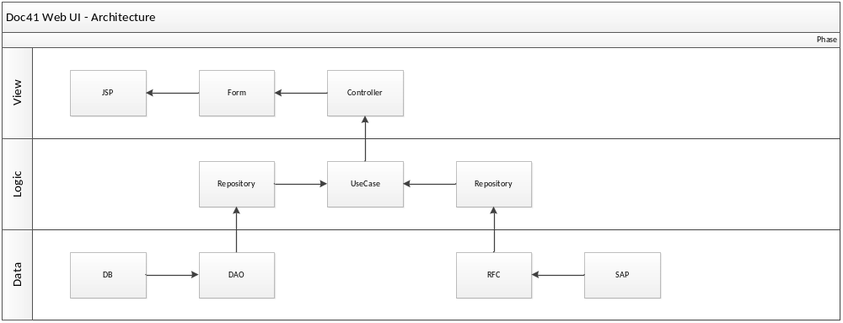
The page visible in the browser of the user is an html document which was constructed from a JSP-File for the design and a Form class containing the data of the page.
A controller class controls which pages are visible to the user and what data will be put into the form class to be displayed in the page.
The use case will do the logic and manage all requests from the controller to receive data. The use case connects to different repositories to retrieve data from database and/or SAP-Systems.
The repository takes the data retrieve request from the use case and performs a call to a DAO (data access object) for database request or a call to a RFC (remote function call) and returns the data to the use case.

Framework
Doc41WebUI is built upon the Spring Framework: http://spring.io and MSC Foundation.

Scope Description
Please define here the scope of this document. Please specify for which areas, systems, etc. this document is applicable. If there are exclusions from the scope, please also explicitly state them here.

For the description of the scope please see the URS related to this process step:
URS-Development_ID-Please enter the title of the Development UPDATE WHEN KNOWN

Terms and Definitions
Please make sure, that all terms, definitions, abbreviations and acronyms that may be helpful for understanding this document are listed. You may add some very specific terms and definitions to the table below. Otherwise please fill in “N/A”.

Term | Definition
N/A | N/A

Cross References
Please list all related Process Steps, Customizing Objects and other Design Specifications
Only list process steps where this DS is explicitly referenced in a realization statement in the FS for that process step. Do NOT list process steps which are just loosely connected to this development.
Also list all Customizing Objects in which settings have to be made for this development. The details on the customizing should be mentioned in that Configuration Document.
Also list other developments which are related to this development.

Related Process Steps | N/A
Related Customizing Objects | N/A
Related other Developments | N/A
Related Functional Specifications | FS-Doc41 Web UI.doc

Programming Specification
In the following sections please specify the development. There are different sections for different kinds of developments:
- Forms / Reports
- Interfaces
Package: new description by SAP for previously Development Class.
Chapter 5.1 is intended for form or report development specification. Chapter 5.2 is intended for interface development. The unused chapter should be marked with N/A in the first line of the table.

Form / Report Specification
Title: | Download: Air waybill
Short description: | Carrier: Download: Air waybill
Package | N/A
Enhancement Points | N/A
Transaction code | N/A
Type of program | Java Program
Message Class | N/A
Affected tables / fields: | N/A
Description of selection criteria: | N/A

Design of the form:
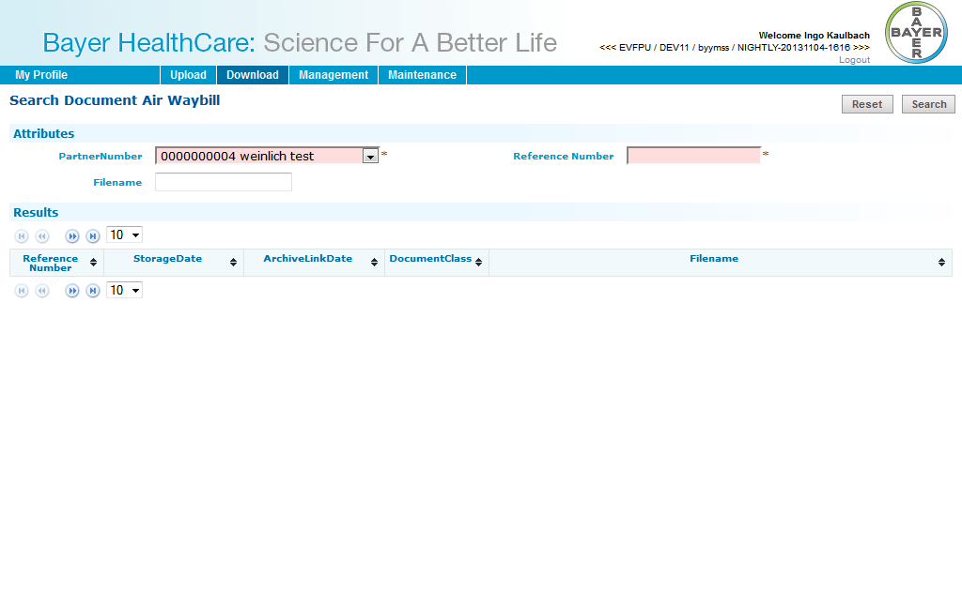
You have to enter Partner number and Reference number.
Optional you can enter filename.
Then you can search for the document and download it.

Data Dictionary Objects (DDIC)
N/A

Title: | Download: Bill of Lading
Short description: | Carrier: Bill of Lading
Package | N/A
Enhancement Points | N/A
Transaction code | N/A
Type of program | Java Program
Message Class | N/A
Affected tables / fields: | N/A
Description of selection criteria: | N/A

Design of the form:
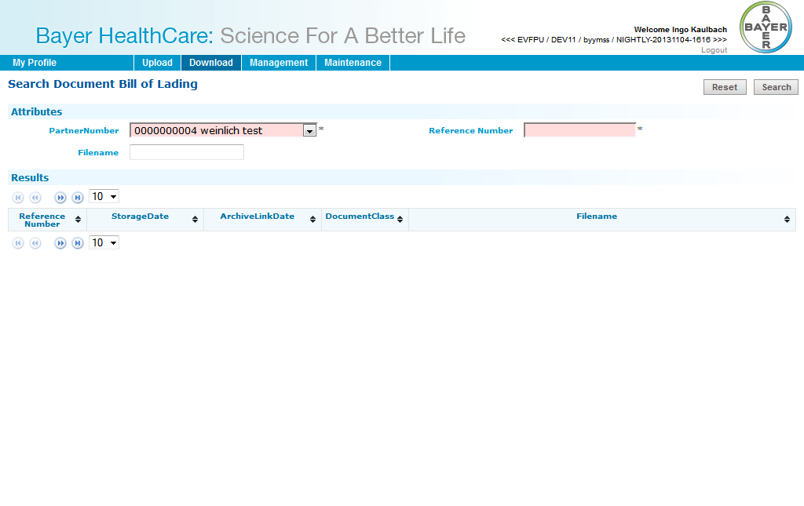
You have to enter Partner number and Reference number.
Optional you can enter filename.
Then you can search for the document and download it.

Data Dictionary Objects (DDIC)
N/A

Title: | Download: Shippers declaration
Short description: | Carrier: Download: Shippers declaration
Package | N/A
Enhancement Points | N/A
Transaction code | N/A
Type of program | Java Program
Message Class | N/A
Affected tables / fields: | N/A
Description of selection criteria: | N/A

Design of the form:
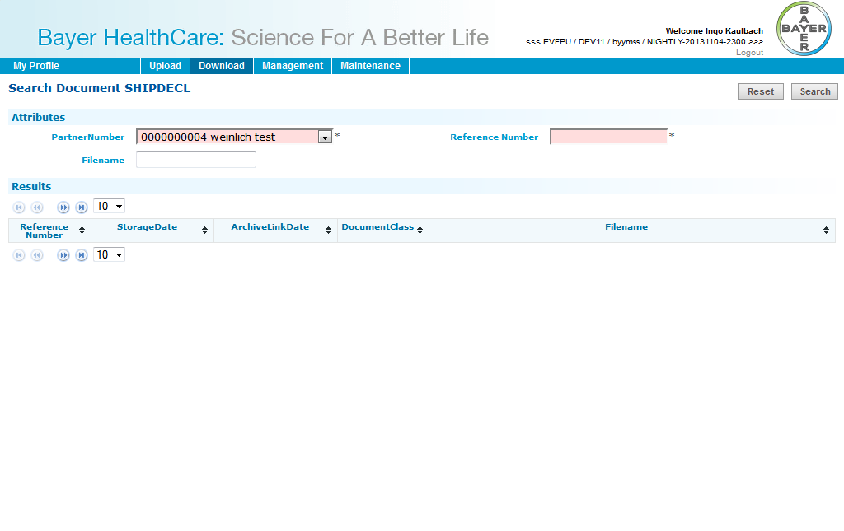
You have to enter Partner number and Reference number.
Optional you can enter filename.
Then you can search for the document and download it.

Data Dictionary Objects (DDIC)
N/A

Title: | Download: Waybill
Short description: | Carrier: Download: Waybill
Package | N/A
Enhancement Points | N/A
Transaction code | N/A
Type of program | Java Program
Message Class | N/A
Affected tables / fields: | N/A
Description of selection criteria: | N/A

Design of the form:
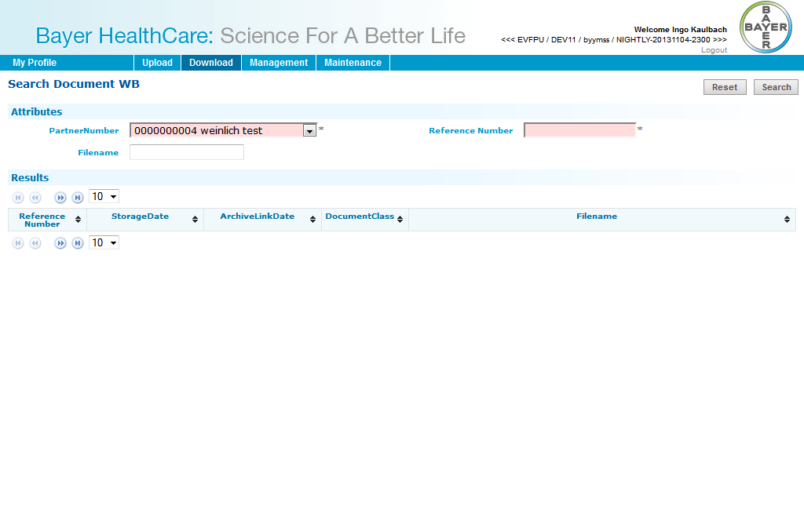
You have to enter Partner number and Reference number.
Optional you can enter filename.
Then you can search for the document and download it.

Data Dictionary Objects (DDIC)
N/A

Title: | Download: FDA certificate
Short description: | Carrier: Download: FDA certificate
Package | N/A
Enhancement Points | N/A
Transaction code | N/A
Type of program | Java Program
Message Class | N/A
Affected tables / fields: | N/A
Description of selection criteria: | N/A

Design of the form:
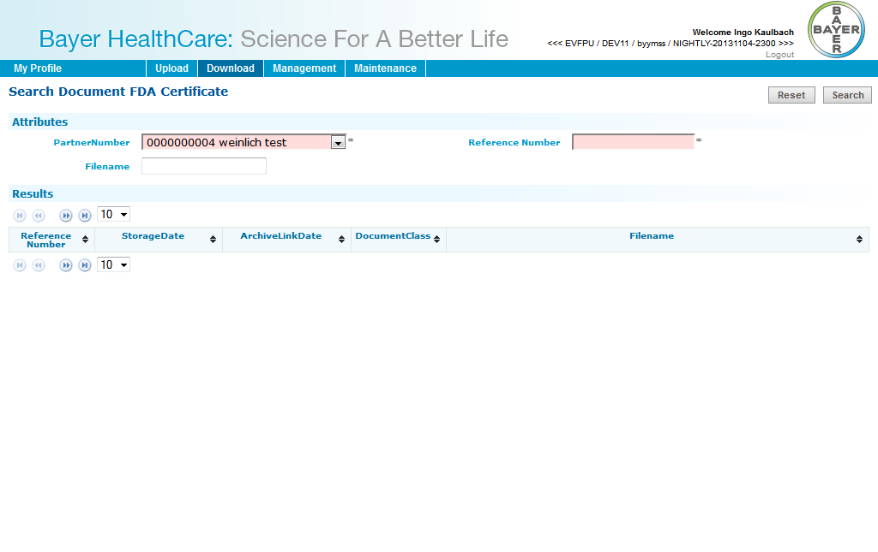
You have to enter Partner number and Reference number.
Optional you can enter filename.
Then you can search for the document and download it.

Data Dictionary Objects (DDIC)
N/A

Title: | Download: CMR (outgoing)
Short description: | Carrier: Download: CMR (outgoing)
Package | N/A
Enhancement Points | N/A
Transaction code | N/A
Type of program | Java Program
Message Class | N/A
Affected tables / fields: | N/A
Description of selection criteria: | N/A

Design of the form:
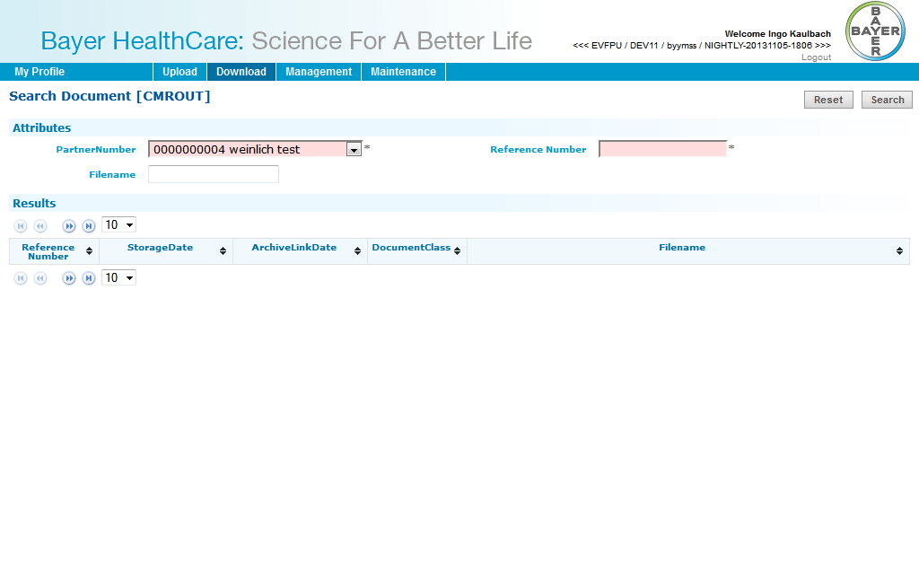
You have to enter Partner number and Reference number.
Optional you can enter filename.
Then you can search for the document and download it.

Data Dictionary Objects (DDIC)
N/A

Title: | Upload: CMR (incoming)
Short description: | Carrier: Upload: CMR (incoming)
Package | N/A
Enhancement Points | N/A
Transaction code | N/A
Type of program | Java Program
Message Class | N/A
Affected tables / fields: | N/A
Description of selection criteria: | N/A

Design of the form:
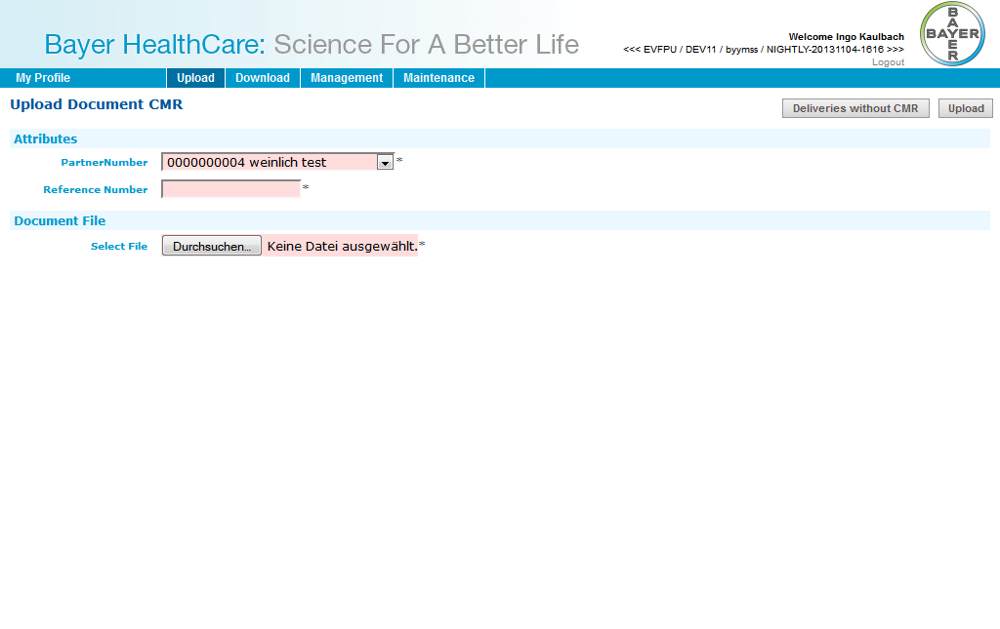
You have to enter Partner number and Reference number.
You have to attache the file than you can upload it.

Data Dictionary Objects (DDIC)
N/A

Title: | Upload: Air waybill
Short description: | Carrier: Upload: Air waybill
Package | N/A
Enhancement Points | N/A
Transaction code | N/A
Type of program | Java Program
Message Class | N/A
Affected tables / fields: | N/A
Description of selection criteria: | N/A

Design of the form:
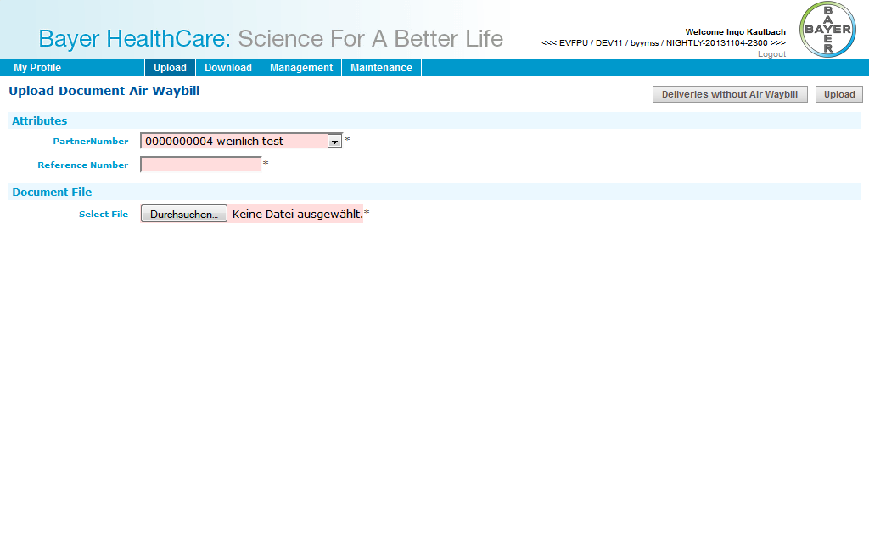
You have to enter Partner number and Reference number.
You have to attache the file than you can upload it.

Data Dictionary Objects (DDIC)
N/A

Title: | Upload: Bill of Lading
Short description: | Carrier: Upload: Bill of Lading
Package | N/A
Enhancement Points | N/A
Transaction code | N/A
Type of program | Java Program
Message Class | N/A
Affected tables / fields: | N/A
Description of selection criteria: | N/A

Design of the form:
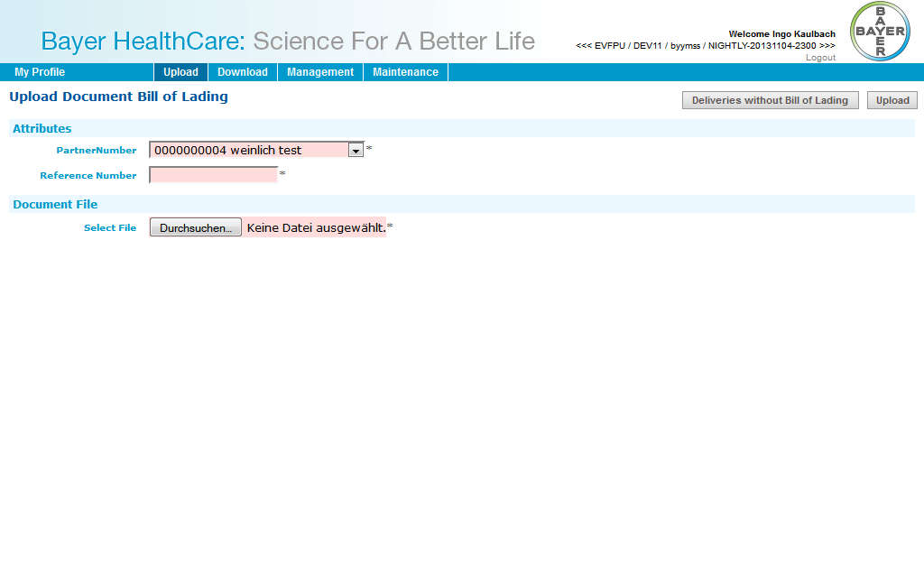
You have to enter Partner number and Reference number.
You have to attache the file than you can upload it.

Data Dictionary Objects (DDIC)
N/A

Title: | Download: Air waybill
Short description: | Customs Broker: Download: Air waybill
Package | N/A
Enhancement Points | N/A
Transaction code | N/A
Type of program | Java Program
Message Class | N/A
Affected tables / fields: | N/A
Description of selection criteria: | N/A

Design of the form:
No screen design, this is a direct download.
You have to click on a given link and can directy download the document.

Data Dictionary Objects (DDIC)
N/A

Title: | Download: Bill of Lading
Short description: | Customs Broker: Download: Bill of Lading
Package | N/A
Enhancement Points | N/A
Transaction code | N/A
Type of program | Java Program
Message Class | N/A
Affected tables / fields: | N/A
Description of selection criteria: | N/A

Design of the form:
No screen design, this is a direct download.
You have to click on a given link and can directy download the document.

Data Dictionary Objects (DDIC)
N/A

Title: | Download: Shippers declaration
Short description: | Customs Broker: Download: Shippers declaration
Package | N/A
Enhancement Points | N/A
Transaction code | N/A
Type of program | Java Program
Message Class | N/A
Affected tables / fields: | N/A
Description of selection criteria: | N/A

Design of the form:
No screen design, this is a direct download.
You have to click on a given link and can directy download the document.

Data Dictionary Objects (DDIC)
N/A

Title: | Download: Waybill
Short description: | Customs Broker: Download: Waybill
Package | N/A
Enhancement Points | N/A
Transaction code | N/A
Type of program | Java Program
Message Class | N/A
Affected tables / fields: | N/A
Description of selection criteria: | N/A

Design of the form:
No screen design, this is a direct download.
You have to click on a given link and can directy download the document.

Data Dictionary Objects (DDIC)
N/A

Title: | Download: FDA certificate
Short description: | Customs Broker: Download: FDA certificate
Package | N/A
Enhancement Points | N/A
Transaction code | N/A
Type of program | Java Program
Message Class | N/A
Affected tables / fields: | N/A
Description of selection criteria: | N/A

Design of the form:
No screen design, this is a direct download.
You have to click on a given link and can directy download the document.

Data Dictionary Objects (DDIC)
N/A

Title: | Upload: Supplier CoA
Short description: | Material Supplier: Upload: Supplier CoA
Package | N/A
Enhancement Points | N/A
Transaction code | N/A
Type of program | Java Program
Message Class | N/A
Affected tables / fields: | N/A
Description of selection criteria: | N/A

Design of the form:
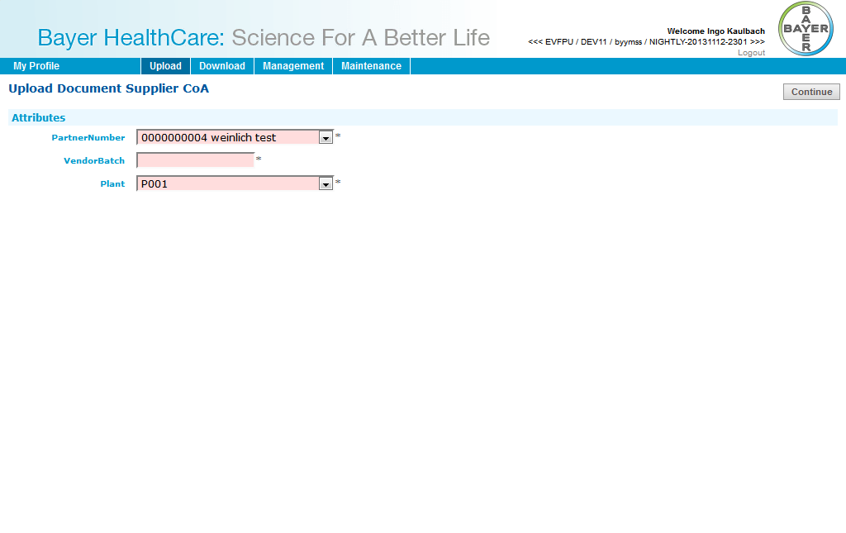
You have to enter Partner number, vendor batch and plant.
You have to attache the file than you can upload it.

Data Dictionary Objects (DDIC)
N/A

Title: | Upload: Delivery Certificate
Short description: | Product Supplier: Upload: Delivery Certificate
Package | N/A
Enhancement Points | N/A
Transaction code | N/A
Type of program | Java Program
Message Class | N/A
Affected tables / fields: | N/A
Description of selection criteria: | N/A

Design of the form:
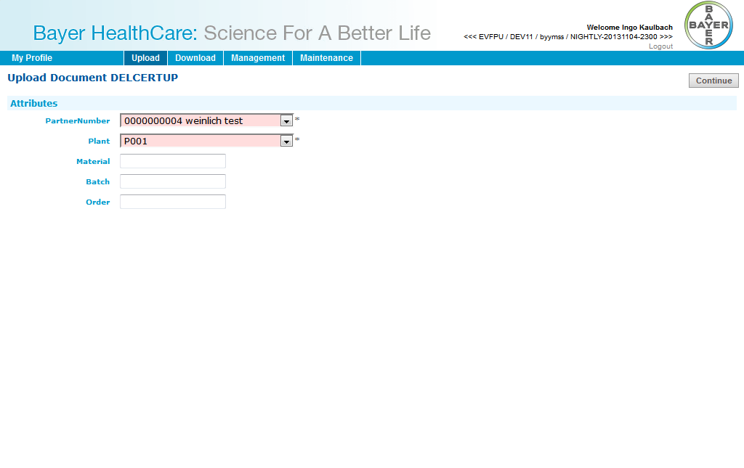
You have to enter Partner number and plant.
Optional you can enter material, batch and order.
You have to attache the file than you can upload it.

Data Dictionary Objects (DDIC)
N/A

Title: | Download: Delivery Certificate
Short description: | Viewer Country: Download: Delivery Certificate
Package | N/A
Enhancement Points | N/A
Transaction code | N/A
Type of program | Java Program
Message Class | N/A
Affected tables / fields: | N/A
Description of selection criteria: | N/A

Design of the form:
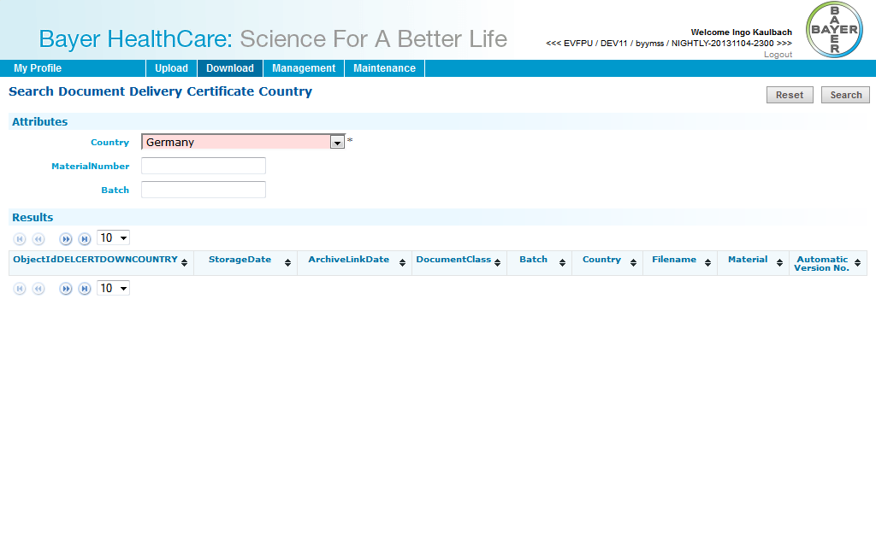
You have to enter country.
Optional you can enter material number and batch.
Then you can search for the document and download it.

Data Dictionary Objects (DDIC)
N/A

Title: | Download: Delivery Certificate
Short description: | Viewer Country: Download: Delivery Certificate
Package | N/A
Enhancement Points | N/A
Transaction code | N/A
Type of program | Java Program
Message Class | N/A
Affected tables / fields: | N/A
Description of selection criteria: | N/A

Design of the form:
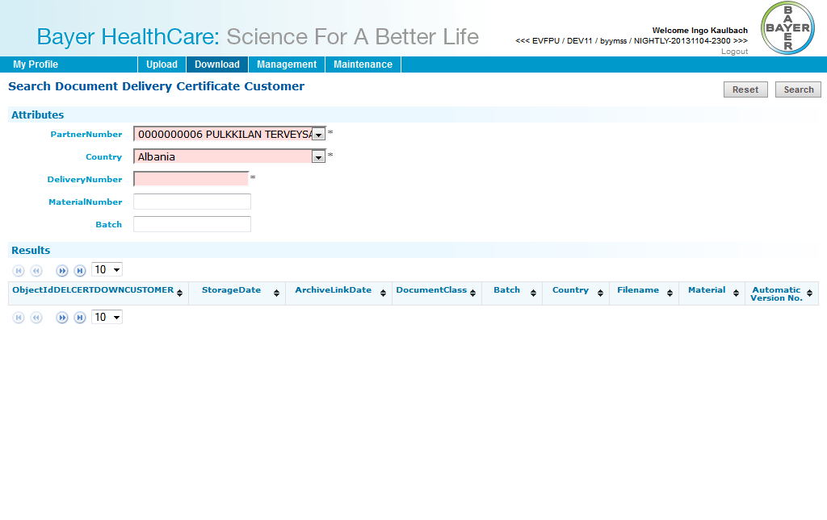
You have to enter Partner number, country and delivery number.
Optional you can enter material number and batch.
Then you can search for the document and download it.

Data Dictionary Objects (DDIC)
N/A

Title: | Download: HighRes Layout
Short description: | Layout Supplier: Download: HighRes Layout
Package | N/A
Enhancement Points | N/A
Transaction code | N/A
Type of program | Java Program
Message Class | N/A
Affected tables / fields: | N/A
Description of selection criteria: | N/A

Design of the form:
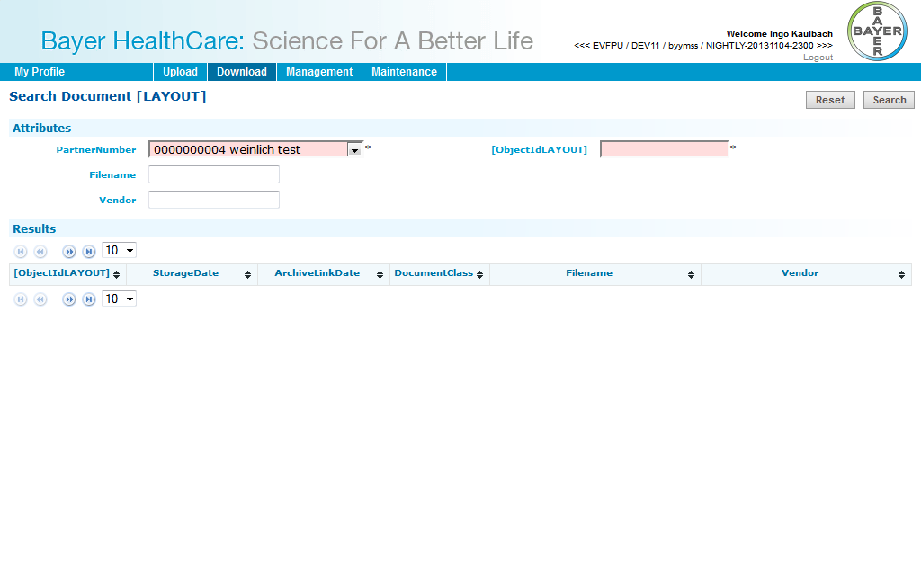
You have to enter Partner number and object id.
Optional you can enter filename and vendor.
Then you can search for the document and download it.

Data Dictionary Objects (DDIC)
N/A

Title: | Download: LowRes Artwork
Short description: | Layout Supplier: Download: LowRes Artwork
Package | N/A
Enhancement Points | N/A
Transaction code | N/A
Type of program | Java Program
Message Class | N/A
Affected tables / fields: | N/A
Description of selection criteria: | N/A

Design of the form:
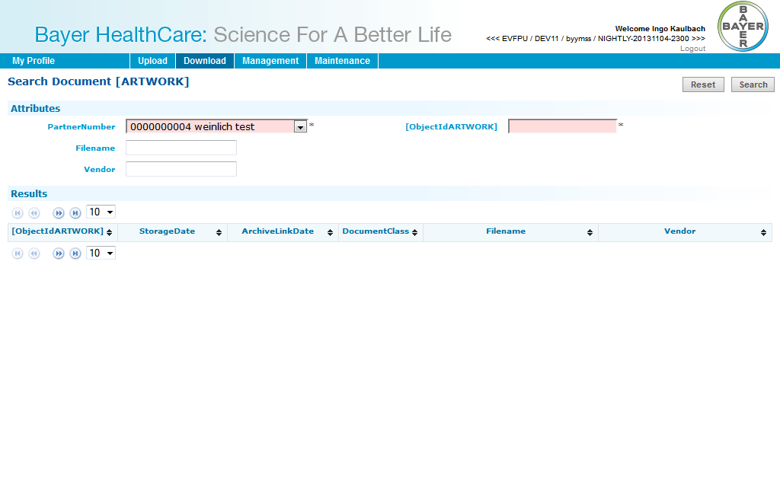
You have to enter Partner number and object id.
Optional you can enter filename and vendor.
Then you can search for the document and download it.

Data Dictionary Objects (DDIC)
N/A

Title: | Upload: HighRes Layout
Short description: | Layout Supplier: Upload: HighRes Layout
Package | N/A
Enhancement Points | N/A
Transaction code | N/A
Type of program | Java Program
Message Class | N/A
Affected tables / fields: | N/A
Description of selection criteria: | N/A

Design of the form:
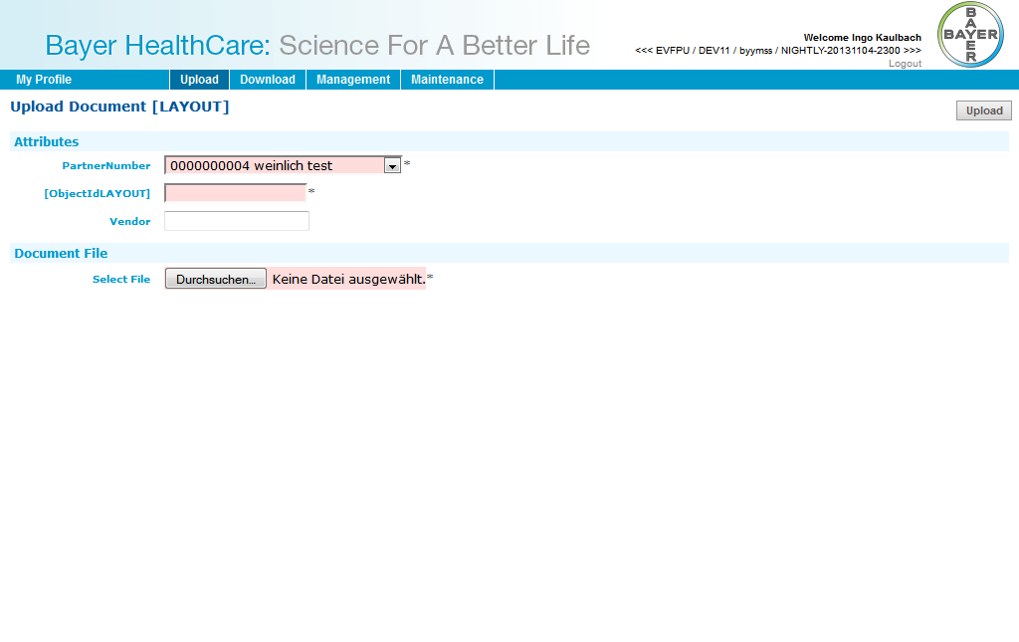
You have to enter Partner number and opbject id.
Optional you can enter vendor.
You have to attache the file than you can upload it.

Data Dictionary Objects (DDIC)
N/A

Title: | Download: Packaging specification
Short description: | PM Supplier: Download: Packaging specification
Package | N/A
Enhancement Points | N/A
Transaction code | N/A
Type of program | Java Program
Message Class | N/A
Affected tables / fields: | N/A
Description of selection criteria: | N/A

Design of the form:
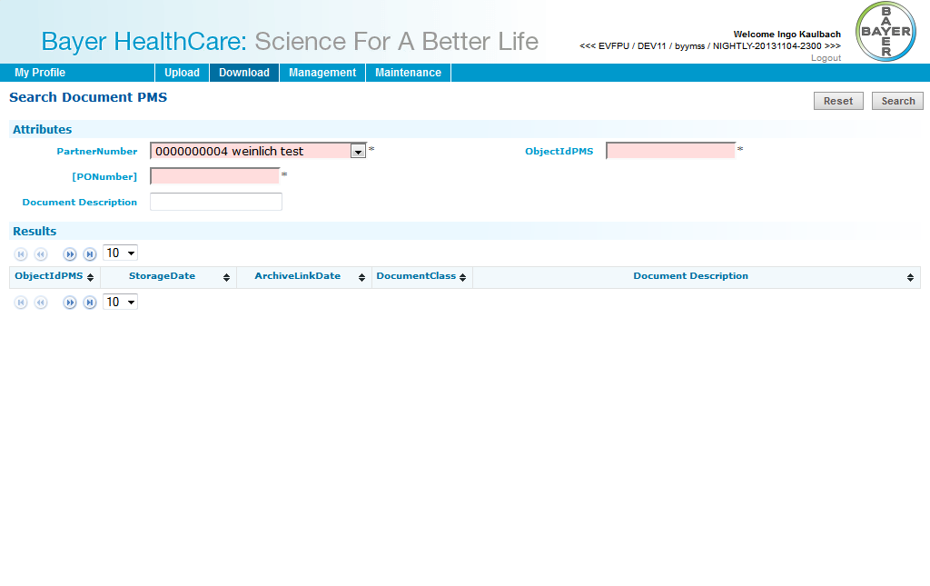
You have to enter Partner number, purchase order number and object id.
Optional you can enter document description.
Then you can search for the document and download it.

Data Dictionary Objects (DDIC)
N/A

Title: | Download: Technical drawing
Short description: | PM Supplier: Download: Technical drawing
Package | N/A
Enhancement Points | N/A
Transaction code | N/A
Type of program | Java Program
Message Class | N/A
Affected tables / fields: | N/A
Description of selection criteria: | N/A

Design of the form:
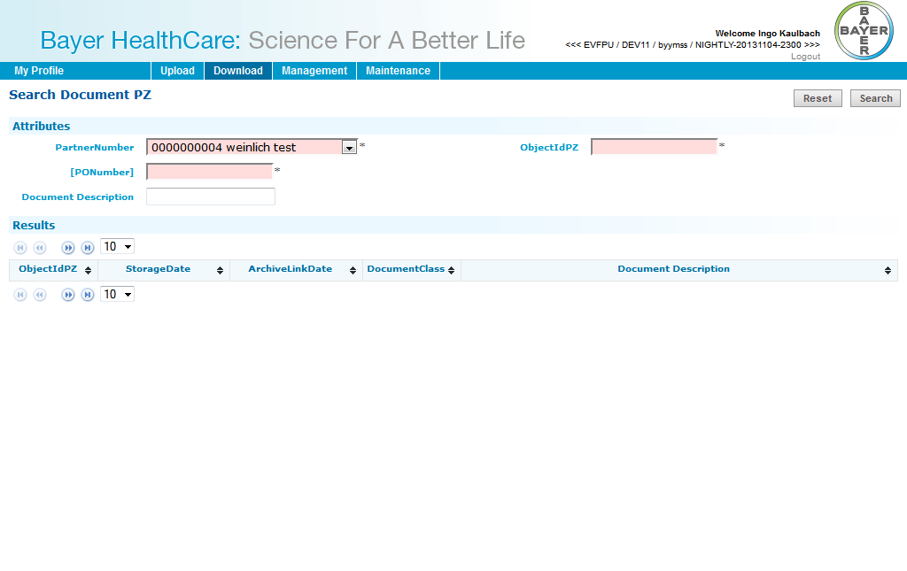
You have to enter Partner number, purchase order number and object id.
Optional you can enter document description.
Then you can search for the document and download it.

Data Dictionary Objects (DDIC)
N/A

Title: | Download: Technical packaging and Delivery requirements
Short description: | PM Supplier: Download: Technical packaging and Delivery requirements
Package | N/A
Enhancement Points | N/A
Transaction code | N/A
Type of program | Java Program
Message Class | N/A
Affected tables / fields: | N/A
Description of selection criteria: | N/A

Design of the form:
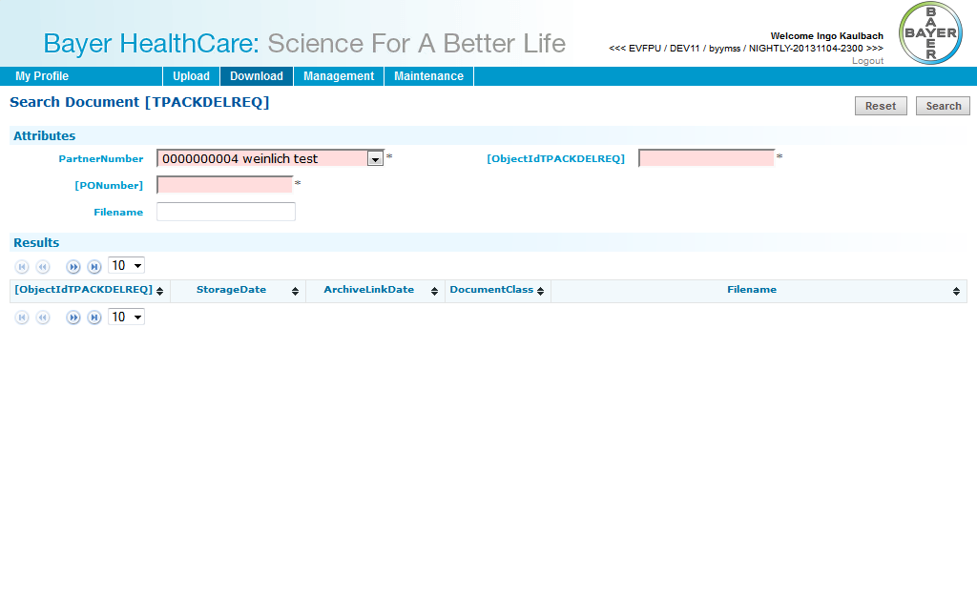
You have to enter Partner number, purchase order number and object id.
Optional you can enter document description.
Then you can search for the document and download it.

Data Dictionary Objects (DDIC)
N/A

Title: | User Overview
Short description: | User Management: User Overview
Package | N/A
Enhancement Points | N/A
Transaction code | N/A
Type of program | Java Program
Message Class | N/A
Affected tables / fields: | N/A
Description of selection criteria: | N/A

Design of the form:
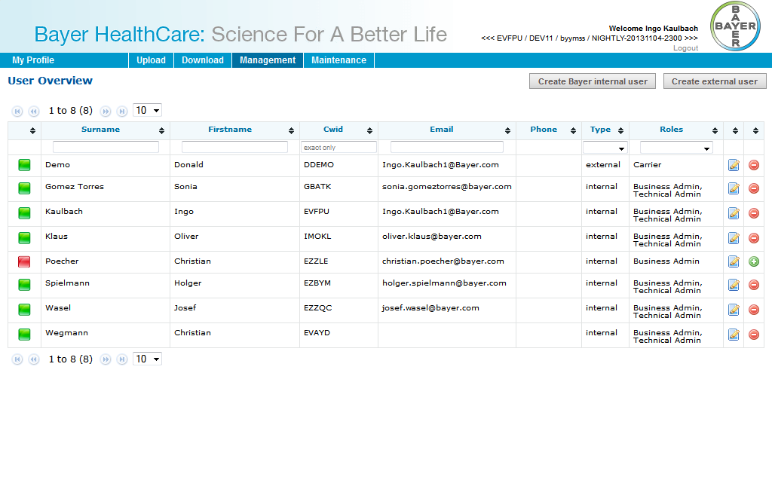
This screen shows an overview of all users.
The users can be filtered by entering values in the header filter fields.
The users can be sorted by clicking on the in the header fields.
The first icon indicates the status of the user: green for active, red for inactive. This status can be toggled by clicking the red/green icon in the last column. The icon in the second to last column opens the edit dialog.
There are two buttons to create an internal or external user.

Data Dictionary Objects (DDIC)
N/A

Title: | Create internal user
Short description: | User Management: Create internal user – Page 1
Package | N/A
Enhancement Points | N/A
Transaction code | N/A
Type of program | Java Program
Message Class | N/A
Affected tables / fields: | N/A
Description of selection criteria: | N/A

Design of the form:
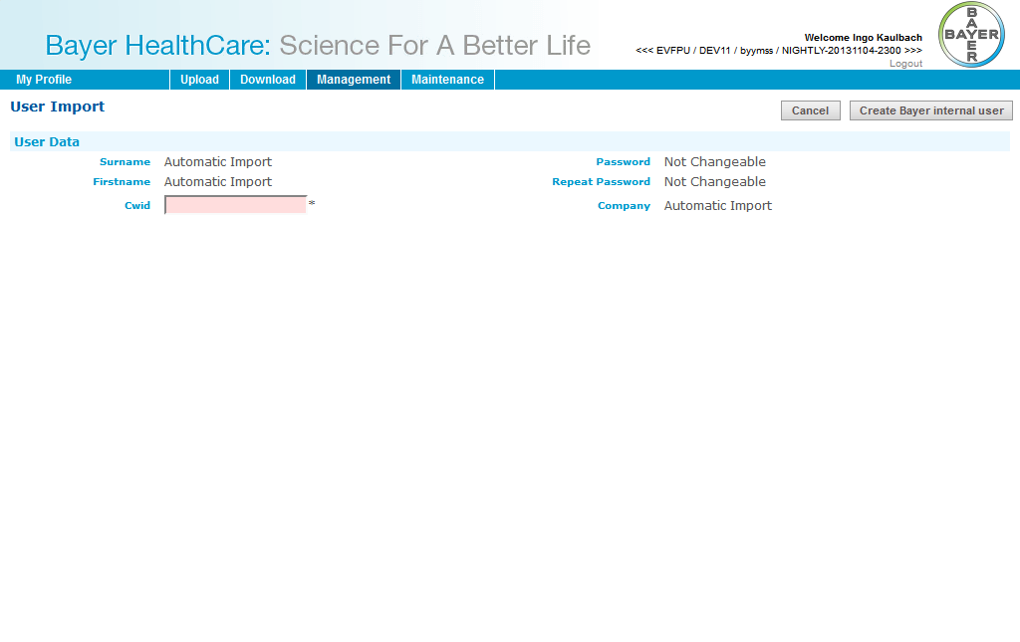
This screen is used for importing internal (=Bayer) users into the system. After a CWID is inserted and “Create Bayer internal user” is clicked, the Import Screen will be shown.

Data Dictionary Objects (DDIC)
N/A

Title: | Create internal user
Short description: | User Management: Create internal user – Page 2
Package | N/A
Enhancement Points | N/A
Transaction code | N/A
Type of program | Java Program
Message Class | N/A
Affected tables / fields: | N/A
Description of selection criteria: | N/A

Design of the form:
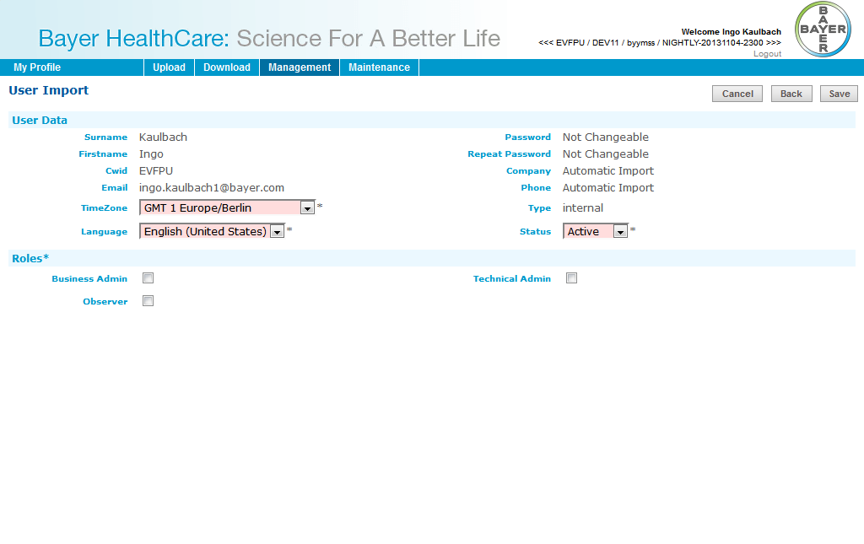
Time zone, language and status of the user have to be set. Only active users can log into Doc41WebUI.

An internal user can have following roles:
- Business Admin
- Technical Admin
- Observer

Cancel will go back to user overview.
Back will go back to enter another CWID.
Save will create the user.

Data Dictionary Objects (DDIC)
N/A

Title: | Create external user
Short description: | User Management: Create external user
Package | N/A
Enhancement Points | N/A
Transaction code | N/A
Type of program | Java Program
Message Class | N/A
Affected tables / fields: | N/A
Description of selection criteria: | N/A

Design of the form:
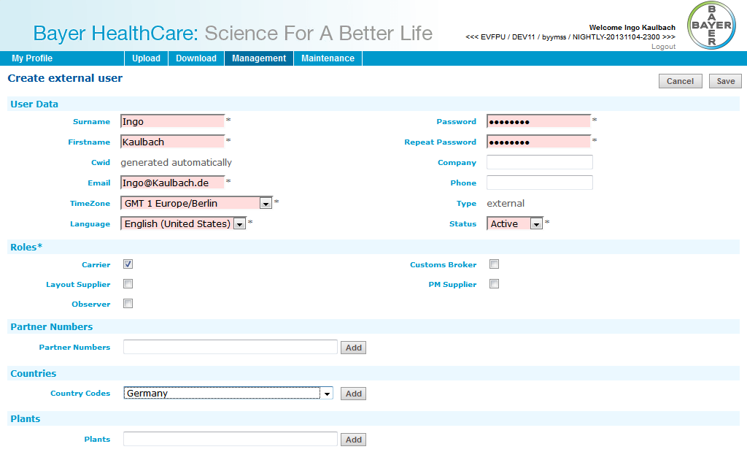
This screen is used for creating external users into the system.
For external users First-, Surname, Email-Address and Password must be entered.

Time zone, language and status of the user have to be set. Only active users can log into Doc41WebUI.

An external user can have following roles:
- Carrier
- Customs Broker
- Material Supplier
- Product Supplier
- Viewer Country
- Viewer Customer
- Layout Supplier
- PM Supplier
- Observer

An external user can have Partner Numbers, Countries and Plants.
Partner Numbers are only numbers (no letters etc.). After click on “Add”-button the partner will be searched in SAP and added to list, if found.
Countries can be added from a list.
Plants can be added as text. A Plant must only have numbers and upper case letters and a maximum length of 4.

Cancel will go back to user overview.
Save will create the user.

Data Dictionary Objects (DDIC)
N/A

Title: | Edit internal user
Short description: | User Management: Edit internal user
Package | N/A
Enhancement Points | N/A
Transaction code | N/A
Type of program | Java Program
Message Class | N/A
Affected tables / fields: | N/A
Description of selection criteria: | N/A

Design of the form:
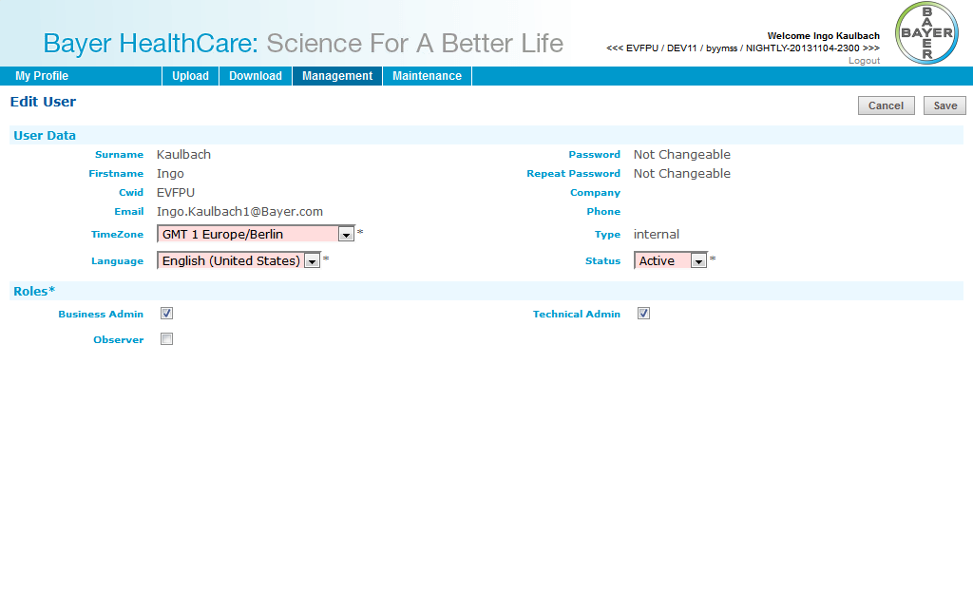
This screen is used to edit data of internal users.

Data Dictionary Objects (DDIC)
N/A

Title: | Edit external user
Short description: | User Management: Edit internal user
Package | N/A
Enhancement Points | N/A
Transaction code | N/A
Type of program | Java Program
Message Class | N/A
Affected tables / fields: | N/A
Description of selection criteria: | N/A

Design of the form:
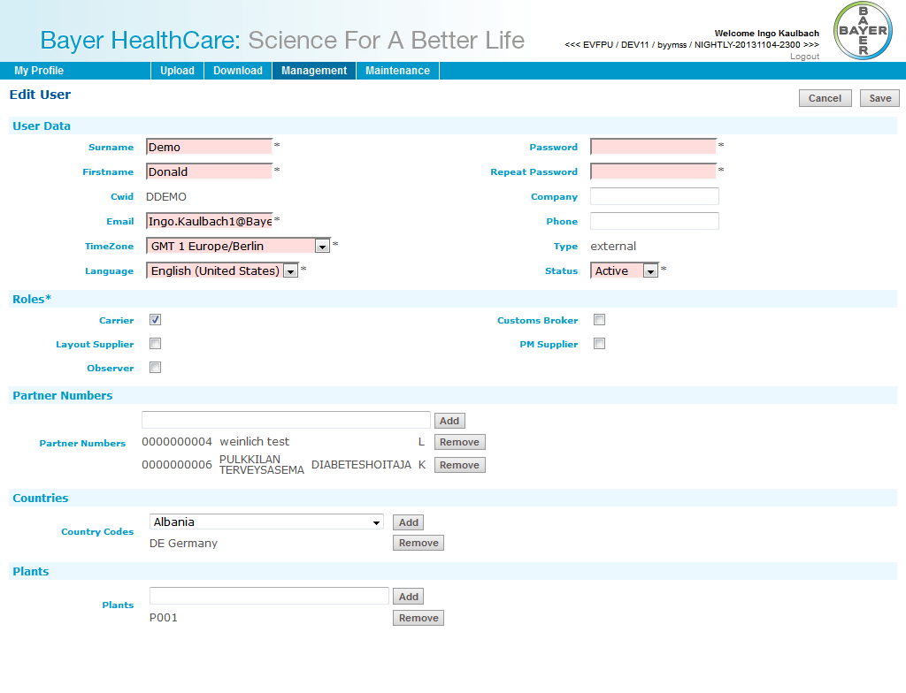
This screen is used to edit data of external users.

Data Dictionary Objects (DDIC)
N/A

Title: | New password for external user
Short description: | User Management: New password for external user
Package | N/A
Enhancement Points | N/A
Transaction code | N/A
Type of program | Java Program
Message Class | N/A
Affected tables / fields: | N/A
Description of selection criteria: | N/A

Design of the form:
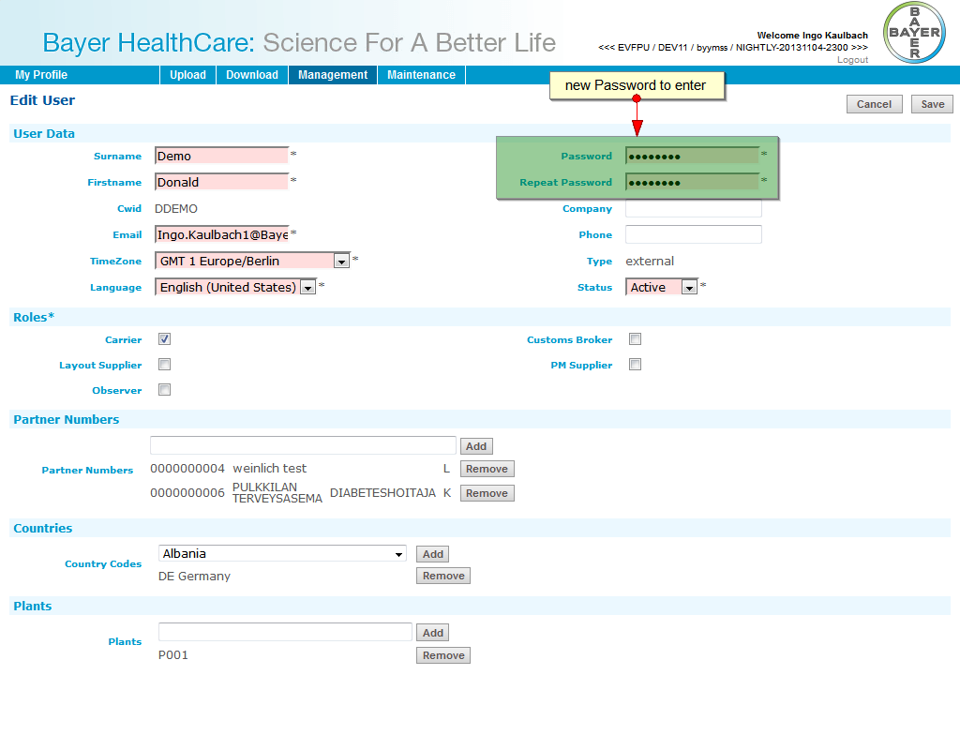
It must be possible for administrators to set a new password for external users.
This can be done in the edit user page for external users.
The administrator has to enter the password, repeat it and save user data.
The user will get an email with the new password.

Data Dictionary Objects (DDIC)
N/A

Interface Specification

Title: |  | GetInspectionLotsForVendorBatch
Short description: |  | Get inspection lots for vendor batch
Interface characteristics:
 | Type of interface | RFC
 | Realization via: | N/A
 | Direction of interface: | N/A
Filter objects |  | N/A
Inbound parameter |  | IV_PLANT  IV_VENDOR  IV_VENDOR_BATCH
Outbound parameter |  | None
Name of interface file: |  | N/A

Title: |  | CheckPartner
Short description: |  | Check partner
Interface characteristics:
 | Type of interface | RFC
 | Realization via: | N/A
 | Direction of interface: | N/A
Filter objects |  | N/A
Inbound parameter |  | IV_LIFNR
Outbound parameter |  | EV_NAME1  EV_NAME2  EV_RETURN
Name of interface file: |  | N/A

Title: |  | GetCrepInfo
Short description: |  | Get content repository info
Interface characteristics:
 | Type of interface | RFC
 | Realization via: | N/A
 | Direction of interface: | N/A
Filter objects |  | N/A
Inbound parameter |  | IV_DOC41ID  IV_DOCTYPE  IV_OBJECT_TYPE
Outbound parameter |  | EV_CONT_REP  EV_DOC_CLASS  EV_RETURNCODE
Name of interface file: |  | N/A

Title: |  | FindDocs
Short description: |  | Find documents
Interface characteristics:
 | Type of interface | RFC
 | Realization via: | N/A
 | Direction of interface: | N/A
Filter objects |  | N/A
Inbound parameter |  | IV_ATT_NAME1  IV_ATT_NAME10  IV_ATT_NAME11  IV_ATT_NAME12  IV_ATT_NAME13  IV_ATT_NAME14  IV_ATT_NAME15  IV_ATT_NAME16  IV_ATT_NAME17  IV_ATT_NAME18  IV_ATT_NAME19  IV_ATT_NAME2  IV_ATT_NAME20  IV_ATT_NAME3  IV_ATT_NAME4  IV_ATT_NAME5  IV_ATT_NAME6  IV_ATT_NAME7  IV_ATT_NAME8  IV_ATT_NAME9  IV_D41ID  IV_GET_MAX_VERS  IV_MAXHIT  IV_OBJ_TYPE1  IV_OBJ_TYPE10  IV_OBJ_TYPE11  IV_OBJ_TYPE12  IV_OBJ_TYPE13  IV_OBJ_TYPE14  IV_OBJ_TYPE15  IV_OBJ_TYPE16  IV_OBJ_TYPE17  IV_OBJ_TYPE18  IV_OBJ_TYPE19  IV_OBJ_TYPE2  IV_OBJ_TYPE20  IV_OBJ_TYPE3  IV_OBJ_TYPE4  IV_OBJ_TYPE5  IV_OBJ_TYPE6  IV_OBJ_TYPE7  IV_OBJ_TYPE8  IV_OBJ_TYPE9
Outbound parameter |  | EV_DOC_COUNT
Name of interface file: |  | N/A

Title: |  | CreateHttpDvsPut
Short description: |  | Create HTTP Dvs Put
Interface characteristics:
 | Type of interface | RFC
 | Realization via: | N/A
 | Direction of interface: | N/A
Filter objects |  | N/A
Inbound parameter |  | IV_COMP_ID  IV_CREP_ID  IV_DOC_ID
Outbound parameter |  | RETURN_CODE  RETURN_MESSAGE  URL
Name of interface file: |  | N/A

Title: |  | GetDocDef
Short description: |  | Get document definition
Interface characteristics:
 | Type of interface | RFC
 | Realization via: | N/A
 | Direction of interface: | N/A
Filter objects |  | N/A
Inbound parameter |  | None
Outbound parameter |  | EV_RETURNCODE
Name of interface file: |  | N/A

Title: |  | GetDeliveriesWithoutDocument
Short description: |  | Get deliveries without document
Interface characteristics:
 | Type of interface | RFC
 | Realization via: | N/A
 | Direction of interface: | N/A
Filter objects |  | N/A
Inbound parameter |  | IV_DATEFORM  IV_DATETO  IV_DOCTYPE_ID  IV_PARNR
Outbound parameter |  | None
Name of interface file: |  | N/A

Title: |  | GetAttrValues
Short description: |  | Get attribut values
Interface characteristics:
 | Type of interface | RFC
 | Realization via: | N/A
 | Direction of interface: | N/A
Filter objects |  | N/A
Inbound parameter |  | IV_LANG
Outbound parameter |  | EV_RETURNCODE
Name of interface file: |  | N/A

Title: |  | CheckArtworkLayoutForVendor
Short description: |  | Check artwork layout for vendor
Interface characteristics:
 | Type of interface | RFC
 | Realization via: | N/A
 | Direction of interface: | N/A
Filter objects |  | N/A
Inbound parameter |  | IV_DOCTYPE_ID  IV_VENDOR
Outbound parameter |  | EV_RETURN
Name of interface file: |  | N/A

Title: |  | CheckDeliveryForPartner
Short description: |  | Check delivery for partner
Interface characteristics:
 | Type of interface | RFC
 | Realization via: | N/A
 | Direction of interface: | N/A
Filter objects |  | N/A
Inbound parameter |  | IV_PARNR  IV_REF_NO
Outbound parameter |  | EV_RETURN  EV_VKORG
Name of interface file: |  | N/A

Title: |  | GetBatchObjectsForSupplier
Short description: |  | Get batch objects for supplier
Interface characteristics:
 | Type of interface | RFC
 | Realization via: | N/A
 | Direction of interface: | N/A
Filter objects |  | N/A
Inbound parameter |  | IV_BATCH  IV_DOCNUMBER  IV_MATNR  IV_PLANT  IV_SUPPLIER
Outbound parameter |  | EV_RETURN
Name of interface file: |  | N/A

Title: |  | ProcessDrReq
Short description: |  | Process Dr Req
Interface characteristics:
 | Type of interface | RFC
 | Realization via: | N/A
 | Direction of interface: | N/A
Filter objects |  | N/A
Inbound parameter |  | ARCHIV_ID  ARC_DOC_ID  AR_DATE  AR_OBJECT  BARCODE  DEL_DATE  DOC_TYPE  MANDANT  OBJECT_ID  SAP_OBJECT  USER_DATA
Outbound parameter |  | ATTCOUNT
Name of interface file: |  | N/A

Title: |  | GetDocUrl
Short description: |  | Get document URL
Interface characteristics:
 | Type of interface | RFC
 | Realization via: | N/A
 | Direction of interface: | N/A
Filter objects |  | N/A
Inbound parameter |  | IV_COMP_ID  IV_CREP_ID  IV_DOC_ID
Outbound parameter |  | EV_DOC_ID_OUT  EV_URL
Name of interface file: |  | N/A

Title: |  | GetDocStatus
Short description: |  | Get document status
Interface characteristics:
 | Type of interface | RFC
 | Realization via: | N/A
 | Direction of interface: | N/A
Filter objects |  | N/A
Inbound parameter |  | IV_COREP  IV_DOCID
Outbound parameter |  | EV_ARDATE  EV_ARTIME  EV_DOCSTATUS  EV_RETURNCODE
Name of interface file: |  | N/A

Title: |  | GetBatchObjectsForCustomer
Short description: |  | Get batch objects for customer
Interface characteristics:
 | Type of interface | RFC
 | Realization via: | N/A
 | Direction of interface: | N/A
Filter objects |  | N/A
Inbound parameter |  | IV_BATCH  IV_COUNTRY  IV_DELIVERY  IV_MATNR  IV_SHIPTO
Outbound parameter |  | None
Name of interface file: |  | N/A

Title: |  | GetAttributes
Short description: |  | Get attributes
Interface characteristics:
 | Type of interface | RFC
 | Realization via: | N/A
 | Direction of interface: | N/A
Filter objects |  | N/A
Inbound parameter |  | D41ID  LANGUAGE
Outbound parameter |  | LCOUNT
Name of interface file: |  | N/A

Title: |  | GetTexts
Short description: |  | Get texts
Interface characteristics:
 | Type of interface | RFC
 | Realization via: | N/A
 | Direction of interface: | N/A
Filter objects |  | N/A
Inbound parameter |  | IV_LANG
Outbound parameter |  | EV_RETURNCODE
Name of interface file: |  | N/A

Title: |  | CreateHttpPut
Short description: |  | Create HTTP put
Interface characteristics:
 | Type of interface | RFC
 | Realization via: | N/A
 | Direction of interface: | N/A
Filter objects |  | N/A
Inbound parameter |  | CREP_ID  DOC_ID
Outbound parameter |  | RETURN_CODE  RETURN_MESSAGE  URL
Name of interface file: |  | N/A

Title: |  | CheckPOAndMaterialForVendor
Short description: |  | Check purchase order and material for vendor
Interface characteristics:
 | Type of interface | RFC
 | Realization via: | N/A
 | Direction of interface: | N/A
Filter objects |  | N/A
Inbound parameter |  | IV_MATNR  IV_PONUMBER  IV_VENDOR
Outbound parameter |  | EV_RETURN
Name of interface file: |  | N/A

Title: |  | GetDocInfo
Short description: |  | Get document info
Interface characteristics:
 | Type of interface | RFC
 | Realization via: | N/A
 | Direction of interface: | N/A
Filter objects |  | N/A
Inbound parameter |  | IV_CREP_ID  IV_DOC_ID
Outbound parameter |  | EV_RETURNCODE
Name of interface file: |  | N/A

Attachments
Please list here all attachments to this document. Fill in N/A if the document has no attachments

- N/A

Further Information
Please use this section to add information that does not fit in any of the other sections. Use it especially to add complex details (e.g. tables) which do not have enough room in the functional realization table.
Do NOT put information in here, which will be already covered in further documentation as the Design Specification for Developments or the Configuration Documents.
Fill in N/A if the document neither has an annex nor any further information.

- N/A

